DAVID
h1, d1, d2, d3, d4, d17

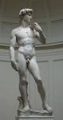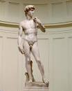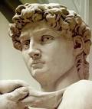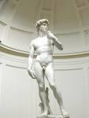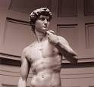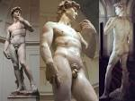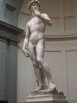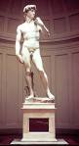
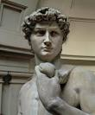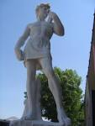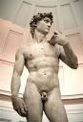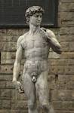
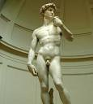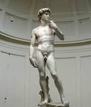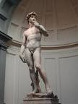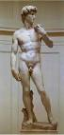
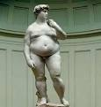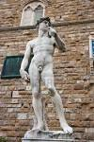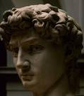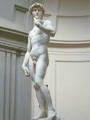
econ.ohio-state.edu  Side, or ventral view of David  1071 × 2046 – 364 kB - jpg | entertainment.howstuff...  Michelangelo's David, a marble  400 × 498 – 45 kB - jpg | caravaggista.com  Michelangelo, David (detail)  678 × 808 – 190 kB - jpg | en.wikipedia.org  File:Michelangelos David.jpg  1200 × 1600 – 174 kB - jpg

David  http://www.google.cz/images?q=michelangelo+david+sculpture&rls=com.microsoft%3Acs&oe=UTF-8&startIndex=&startPage=1&hl=cs&sa=X&oi=image_result_group  http://www.google.cz/imgres?imgurl=http://caravaggista.com/wp-content/uploads/2011/09/michelangelo_david_head.jpg&imgrefurl=http://caravaggista.com/tag/michelangelo/&usg=__E5cnUxq6QVPARiNStp2IDICsAaM=&h=808&w=678&sz=190&hl=cs&start=3&zoom=1&tbnid=_seCsBR2K5xCnM:&tbnh=143&tbnw=120&ei=CifQUKDuC9C10QXCzIDgCg&prev=/images%3Fq%3Dmichelangelo%2Bdavid%2Bsculpture%26hl%3Dcs%26sa%3DX%26rls%3Dcom.microsoft:cs%26tbm%3Disch&itbs=1  entertainment.howstuff...  Michelangelo's David, Detail  400 × 370 – 38 kB – jpg | maryckhayes.wordpress.com  Michelangelo's "David," 1504  1024 × 768 – 100 kB - jpg | ohmygodot.blogspot.com  Michelangelo responded by  450 × 600 – 31 kB - jpg | pbs.org  David, Michelangelo, sculpture  544 × 1000 – 64 kB - jpg

art-prints-on-demand.com  Michelangelo  455 × 550 – 51 kB - jpg | sculptureartgallery.com  DAVID SCULPTURE STATUE  1944 × 2592 – 1582 kB - jpg | guardian.co.uk  Michelangelo: David  308 × 450 – 46 kB - jpg | 123rf.com  Statue of David by  786 × 1200 – 154 kB - jpg
destination360.com  Statue Of David  415 × 462 – 33 kB - jpg | brendajeansblog.wordpr...  Michelangelo's Sculpture of  960 × 1121 – 32 kB - jpg | neoneocon.com  Two Davids. There's this:  614 × 819 – 68 kB - jpg | grafiksaati.com  David Sculpture  367 × 762 – 20 kB - jpg
richardclover.co.uk  Michelangelo's David is  344 × 363 – 21 kB - jpg | 123rf.com  Replica of the David statue by  801 × 1200 – 259 kB - jpg | ibiblio.org  David  545 × 624 – 36 kB - jpg | wolfiewolfgang.com  David but Michelangelo's  768 × 1024 – 47 kB - jpg

